Analysing the Transition away from Coal in South Africa using a Linked Energy-Economic Model

**Bruno Merven, Faaiqa Hartley, Bryce McCall, Jesse Burton and Jules Schers**

# Abstract

In this paper an improved energy-economic model is used to analyse the transition away from coal and toward renewable energy in South Africa. The model enhancements presented in this paper allow for a more accurate assessment of changing coal costs on potential energy and emissions pathways for South Africa. The better representation of the coal sector provides insights on the timing and magnitude of coal mine and power plant retirements, which are a crucial part of information in developing policies required to ameliorate any negative impacts resulting from the energy transition. These negative impacts currently form a social obstacle to change in energy policy. To illustrate the model advances two potential power generation pathways for South Africa are compared: a least-cost energy mix which does not include new coal power plants; and one where renewable capacity in the power sector is constrained, resulting in ~25GW new coal-fired power plant capacity. A comparison of these scenarios shows that, with rising coal costs and lower coal export demand, persisting with coal-based power generation does not “save jobs” in South Africa at the aggregate level, as higher power investment is required in the constrained scenario. This, combined with the higher electricity price experienced in the constrained scenario, negatively affects the rest of the economy, offsetting any positive gains from continued coal-based power generation.

# Introduction

Least-cost power and energy system optimization models are useful for energy planning needs, as they trade off the costs and benefits of various energy technologies such that a least-cost solution for energy production to meet demand can be obtained. Generally, these models include a single price for coal or coal type which captures the average cost of coal. In South Africa, coal is used by various sectors including the power and refinery sectors as well as industry, and is also sold in the international market. Studies using these models to obtain energy pathways for South Africa, and which concur on the shift away from coal toward renewable energy, have therefore considered average costs to various users, including the power sector, in their analysis of potential energy pathways for the country (see Merven et al., 2018; Wright et al., 2017; Reber et al., 2018).

While this type of analysis is useful in demonstrating the impact of changing costs for coal-based power production technologies that can be compared to other technologies, it may over- or under-estimate the costs attributed to different end-users, including power stations. Coal costs differ based on the product source (costs of production of various mines), the types of contracting arrangements in place, and mode and distance of transport to the end-user. Differences in coal costs may affect which existing or new power stations are included in future energy pathways and impact their lifetime and load factors. Similarly, the economic impacts of different energy pathways for South Africa that do not account for the differences between mines may over- or under-estimate the costs to the economy and employment as well as the timing of these impacts. A more detailed inclusion of the link between coal-mines and power plants in an energy planning analysis strengthens the basis for decisions around the operation, refurbishment and retirement of existing coal plants.

In this paper, the energy and economic models used in the linked modelling approach, initially developed for South Africa in Arndt et al. (2016) and continuously advanced in Merven et al. (2017; 2018; 2019), is further refined such that (i) the link between coal-mines and users is included; (ii) the economic and energy data related to coal and coal mining is better aligned; and (iii) the link between coal demand and production is improved between the energy and economic models. The objective of these advances is twofold. First, to capture more accurately the impacts of changing coal costs on potential energy and emissions pathways for South Africa through the impacts of higher coal prices on the economy and on employment. Second, better representation of the coal sector provides insights on the timing and magnitude of coal-mine and power plant retirements, which are crucial to developing policies required to ameliorate any negative impacts resulting from the energy transition.

The paper proceeds as follows. Section 2 provides an overview of the modelling methodology and data and model adjustments to account for a more detailed coal characterization in the energy model as well as improved alignment in data between the energy and economic models. Section 3 describes the scenarios considered in this paper as well as its key assumptions. Section 4 presents the results and Section 5 concludes.

# Methodology

The hard-linked energy-economic model called SATIMGE (see Arndt et. al, 2016; Merven et al., 2017, Merven et al., 2018; Merven et al., 2019) is used in this analysis to explore the least-cost optimal energy plan for South Africa to 2050. SATIMGE combines an energy optimization model for South Africa, called SATIM (for further details see Hughes et al., 2019), with a recursive dynamic computable general equilibrium (CGE) model of the country, called eSAGE (for further details see Alton et al., 2014). SATIM is a full sector energy systems optimization model based on the MARKAL-TIMES family of models, developed in a collaborative effort under the International Energy Agency’s Energy Technology Systems Analysis Programme (Tosato, 2008); while eSAGE is a CGE model based on the generic static and dynamic models described in Lofgren et al. (2002) and Diao and Thurlow (2012), and is a descendant of the class of CGE models introduced by Dervis et al. (1982). The hard-linked modelling approach is designed to simultaneously address the shortcomings and maintain the attractive features of each model, including the retention of a higher resolution depiction of the economy that is useful for simulating policies and measuring socioeconomic outcomes useful for policymakers. The sections below discuss the changes made to the models, underlying data and model links to include a more detailed representation of the coal-mining sector.

## Data preparation – improving the match on energy and economic coal data

The SATIM model is calibrated with the 2012 Department of Energy balance, with some adjustments made to better match actual primary energy data (Hartley et al., 2019a). The eSAGE model is calibrated using the 2012 social accounting matrix (SAM) developed by van Seventer et al. (2012). To link the SATIM and eSAGE models as done in the linked energy-economic model, SATIMGE, we need to ensure that the two sets of data are consistent with respect to energy production and energy consumption in South Africa. In this paper a concerted effort is made to improve the match on coal use and supply between the two datasets.

The first step to doing this is to create two coal commodities in the SAM such that we distinguish between low-grade and high-grade coal. The SAM has only one commodity – coal. The use of low-grade coal is sector-dependent in South Africa, with the power, refinery and chemicals sectors using only this. Low-grade coal is also used in the coal-mining sector for coal-washing, transforming the low-grade coal into higher grades for exports and industrial use. Information needed to distinguish the use of low- and high-grade coal in the SAM is taken from the energy balance. All other use of coal is high-grade. Of the total coal demanded, ~40% is for high-grade coal and ~60% for low-grade.

Figure 1 below presents the volume and value of coal demanded and supplied in South Africa as per the energy balance and national accounts statistics in 2012. The largest users of coal in volumes are the electricity, export, refinery and mining markets. Other users are primarily in the industry sector, largely iron and steel and non-metallic minerals, although this accounts for just ~10% of total coal available. In value terms, the largest users are the same, although exports are predominate here, as high-grade coal is more expensive than low-grade. Coal supplied to the electricity sector accounts for 30% of total value compared to nearly 50% of total volume. In terms of contribution to real GDP, the high-grade coal-mining sector accounts for more than 60% of the whole coal-mining sector’s contribution (assuming a share proportionate to sales value).

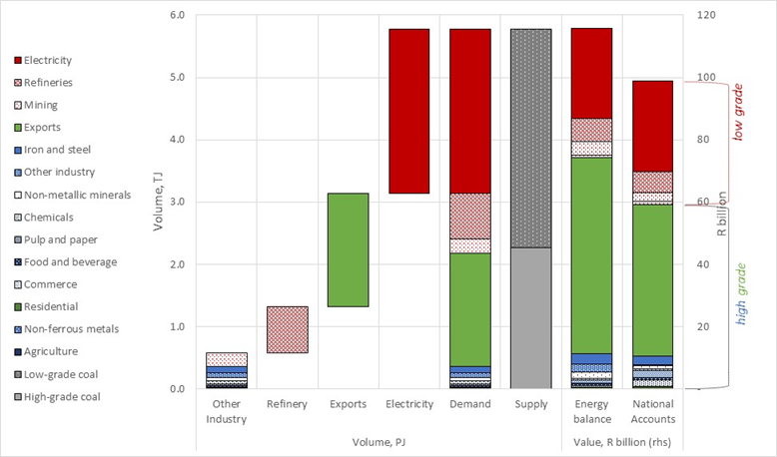

Figure 1: Volume and value of coal demand and supply by sector, 2012

Accounting for the recorded price of anthracite and bituminous coal (i.e. R957 and R222 per ton as per DoE (2012)) as well as the respective calorific factors for coal used in the various sectors, the value of coal demanded according to the energy balance is 17% higher than that reported in the SAM, which is based on the 2012 supply and use tables. In addition, dividing the SAM consumption values by the energy balance volumes, shows differential pricing between sectors (see Figure 2).

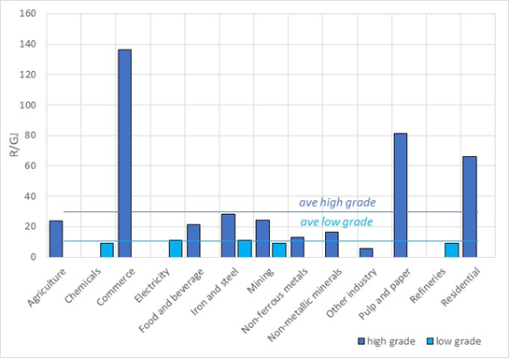

Figure 2: Implied price of coal paid by sector, 2012

CGE models generally use economy-wide prices. As such, each commodity has a single price which is faced by all users. To account for the differential prices in the coal market, a distortion variable is included in the CGE model to capture the premium or subsidy faced by each sector. This is calculated such that the sum of the premiums and subsidies applied net to zero. Imposing such a condition results in the SAM volumes matching more closely to those reported in the energy balance (see Figure 3).

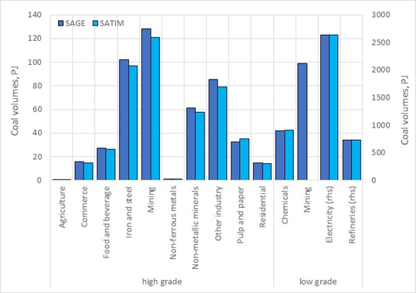

Figure 3: Calibrated CGE model base year volumes compared to the energy balance, 2012

In addition to the changes mentioned above, the changes below were also made to the SAM to account for differences in statistics and simplify model adjustments over time.

* The trade and transport margins for low-grade coal were shifted into the production vector of the electricity sector such that transport expenditure by the sector is equivalent to that reported by Eskom for 2012. Eskom purchases coal from different mines in South Africa. Coal contracts have traditionally been long-term contracts, but more recently an increasing number of shorter-term contracts, with smaller mines, have been in place. The transportation of coal to power plants occurs in a number of ways, including conveyor belt, coal-mine delivery using own or third-party transport; and Eskom transport using own or third party services paid for by Eskom. Based on these differences, the cost of delivery from the coal-mine to Eskom is captured in different parts of the supply and use tables and hence social accounting matrix (EC, 2009). The price of coal purchased for power generation is expected to increase over time as a result of declining resource qualities, increasing operation costs, the need for new capital, and higher transport costs (see Burton et al., 2018). To account for this, this adjustment is made. In the case of refineries, low-grade coal is transported from Sasol’s mines to process facilities via conveyor belt. This cost is captured within Sasol’s expenditure.
* In comparing the SAM to the energy balance, a larger than expected amount of coal was used in the mining sector in the SAM relative to the energy balance. Similarly, the value consumed by the power sector was too low. These were adjusted in line with the energy balance.
* The SAM reports that coal is consumed by freight and passenger transport services. This does not reflect in the energy balance. The consumption of coal, which accounts for 0.06% of freight and passenger transport intermediate consumption, is shifted out of the sector and into the other transport services sector, which comprises ancillary services that support the transport sector. The freight and passenger transport sectors consume more of these support services in return.
* The ability to export low-grade coal is added to the SAM by including a negligible value. This is needed for the economic model to solve while matching the volumes of the energy balance.

## Characterization of the coal and power sectors in SATIM

Figure 4 shows an illustrative diagram of the link between coal-mines and power plants. Some coal-mines supply multiple power plants, and in some cases power plants are supplied from multiple mines, via different transport options, which include conveyor belts, rail and road.

Specific data about existing and new coal contracts found in Dentons (2015) and Steyn et al. (2017) are specified as part of the topology. Transport costs are modelled as a variable cost. Take or pay contracts are specified with fixed annual costs. The optimization algorithm can choose the level of supply from each mine up to the specified maximum annual supply volumes associated with each contract. Contract information was not available for the full coal supply and all contracts run out before the end of the horizon. Generic coal supply options based on Merven et al. (2016) provide the balance. See Burton et al. (2018) for more details.

The characterization of the power sector follows the specifications described in McCall et al. (2019), namely:

* The existing coal plants must either meet the Minimum Emissions Standards (MES) by 2025 or retire, except for the plants that retire before 2030, namely, Hendrina, Komati, Grootvlei, Camden, Arnot and Kriel.
* The same annual build limits and learning rates on the investment costs and availability for PV, Wind, and storage are adopted.
* The natural gas price is set to USD 13 per mbtu (2015 USD).

### 



Figure 4: Illustrative diagram of the link between coal mines and power stations in the SATIM model

## Characterization of the Links between SATIM and eSAGE

As stated above, the linked SATIMGE builds on previous work done (see Arndt et. al, 2016; Merven et al., 2017, Merven et al., 2018; Hartley et al., 2019):

* Theenergy intermediate input coefficients for activities in eSAGE are adjusted as per the results of SATIM.
* The capital supply to the electricity sector in eSAGE is exogenous and based on the results of SATIM.

In this implementation the following refinements are made:

* The power sector in eSAGE:
  + The labour/capital input function is specified as a Leontief, rather than a CES. The labour inputs for the Electricity Sector activity in eSAGE are adjusted based on the power generation mix and the labour intensity of each power generation technology.
* The capital input for the electricity sector in eSAGE is adjusted based on the results of SATIM.
* In the coal sector in eSAGE:
* The capital supply to the coal-mining sector in eSAGE is made exogenous and linked to the results of SATIM.
* The labour/capital inputs of the coal-mining sector in eSAGEare specified as a Leontief function, instead of a CES function.



Figure 5: Illustration of links between coal sector and power sector in eSAGE

## Energy intermediate input coefficients for activities in eSAGE

The composition of intermediate inputs is done using a Leontief representation with the quantity of intermediate input *i* required by activity *a* in year *t*: *qint(a,i,t)* calculated as follows:

*qint(a, i, t) = output(a, t) x ica(a, i, t),*

where *ica(a,i,t)* is a coefficient (which can be time varying) for each intermediate input *i*. For *i*s that are energy commodities, *ica* can be thought of as the energy intensity for activity *a.* The base year (*t0*) *ica* values are derived from the calibrated SAM.

The *ica* coefficients for each energy intermediate input i is calculated from the SATIM results as follows:

*Energy Input (TSector, COM, t)*  = $\sum_{PRC_TSector}{Energy Input (PRC_TSector,COM,t)}$,

*Energy Intensity (TSector, COM, t)*  = $\frac{Energy Input (TSector,COM,t)}{ output(TSector,t)}$,

where *TSector* are the sectors in SATIM (sectors found in the energy balance), *PRC_TSector* are technologies in SATM that belong to *TSector*, and *COM* is the set of energy commodities in SATIM.

Since sectors in SATIM do not exactly match sectors in eSAGE, *ica* coefficients are adjusted via a growth rate rather than in absolute terms. The exception to this is the use of a new fuel not consumed in the base year. Our implementation looks out for such cases (e.g. uptake of hydrogen in transport), and explicitly handles them by setting the *ica* in absolute terms for that particular instance equal to the energy intensity observed in SATIM. For cases where fuel *i* is an input in the base year, the growth in intensity is calculated as follows:

*∆ Energy Intensity (TSector, COM, t)*  = $\frac{Energy Intensity (TSector,COM,t)}{ Energy Intensity (TSector,COM,t-1)}-1$,

This intensity must be mapped from TSector (in SATIM) to a (in eSAGE) as described below if *a* maps to *TSector* and *i* maps to *COM*.

*∆ica (a, i, t)*  = $∆Energy Intensity \left(TSector,COM,t\right)$,

*ica(a, i, t)*  = $ica(a,i,t-1)×\left(1+∆ica \left(a,i,t\right)\right).$

## Specifying the capital supply to the electricity sector in eSAGE

As described in Alton et al. (2014), in eSAGE, a “putty-clay” specification is used by default, where. in between periods, capital stocks for each activity *a* in period *t* is increased based on investment in period *t-1* less depreciation. This new capital is allocated across activities in proportion to the activities’ share of current capital stocks adjusted by its own profit rate relative to the national average profit rate. Once allocated, capital remains fixed in the sector. In the case of the electricity sector capital, stock changes are done differently from other sectors in that they are based on the results of SATIM instead:

Percentage change in capital stock for electricity sector activity in year *t* is calculated by:

*∆qf(capital,elc,t) = ∆TotAnnElcInvCost(t)*,

where *∆TotAnnElcInvCost(t)* is the percentage change in the sum of all annualized investment costs in year *t,* in SATIM technologies that are part of the electricity sector, i.e. all power plants (including storage technologies), transmission and distribution infrastructure.

Capital stock in year t is calculated by:

*qf(capital,elc,t) = qf(capital,elc,t-1) x (1+ ∆qf(capital,elc,t)).*

For the models to be aligned, the base year annualized investment cost *AElcInvCost(t0)*, which does not affect the optimization in SATIM (as it is already sunk capital), needs to be scaled to be equal to *qf(capital,elc,t0)* as observed in the SAM, as part of the calibration process.

For the model link to be more complete, one would ideally adjust the cost of capital (sector-specific discount rate) to be used in SATIM when calculating the annualized investment costs, based on changes in the cost of capital in eSAGE (which is endogenous). However, in the scenarios considered here, we observed that the cost of capital in eSAGE did not fluctuate enough in order to justify this link.

## Adjusting labour and capital inputs for the electricity sector activity in eSAGE

The quantity of primary factor *f* needed by activity *a,* in year *t*, *qf(f,a,t)* is given by:

*qf(f,a,t) = output(a, t) x ifa(f,a,t)*

where *ifa(f,a,t)* is a coefficient for each primary factor *f*, which can be thought of as the labour intensity for f ∈ flabour, and capital intensity for f ∈ fcapital for each activity *a*.

## Labour intensity for the electricity sector in eSAGE

The total direct employment in the electricity sector in the base year (2012) obtained from the Labour Market Dynamics Survey is 72 000 employees. The electricity sector activity comprises three main sub-activities activities, namely: generation, transmission and distribution. The National Energy Regulator (NERSA, 2012) provides a breakdown of employment by sub-activity for municipalities and Eskom, which excludes “Eskom Rotek” and other corporate employees. We reallocate the latter (split equally three-ways) for modelling purposes, between the 3 activities to match the Labour Force Survey. Figure 6 below shows the employment profile by the sector between the three sub-activities, namely 15 000 employees for generation, 10 000 for transmission and other corporate, and 47 000 for distribution.

Figure 6: Employment profile by electricity sector activity in 2012

Direct employment in the electricity sector is more strongly linked to installed capacity than production, as production from a facility may vary from year to year depending on system requirements and plant availability. Installed capacity is not tracked in eSAGE, but it is in SATIM. We thus calculate the employment intensity, *ifa*, aggregated over all the technology types and three sub-activities based on capacity results from SATIM, where a breakdown between the three sub-activities (and by generation technology type for the generation activity), is available. Although some data is available on a power plant basis (Eskom, cited Steyn et al, 2017), we could not reconcile it with the data from NERSA or the labour force survey and instead applied a uniform employment intensity across all existing power plants, (except for nuclear, where data can be found (Eskom, 2019)).

Table 1 shows the 2012 base year direct employment, capacity and employment intensity estimates. The transmission peak demand in 2012, and the distribution capacities are based on the sector peak demands in 2012. A higher employment intensity is assumed for the residential sector, which constitutes the bulk of the municipal distribution volumes.

Table 1: Base year (2012) derived employment intensities by sub-activity

|  |  |  |  |
| --- | --- | --- | --- |
|  | Employment ('000) | Capacity (GW) | Employment Intensity (‘000s/GW) |
| Total generation | 15.2 | 43.9 | 0.35 |
| Nuclear | 1.2 | 1.9 | 0.65 |
| Other | 14.0 | 42.1 | 0.33 |
| Transmission | 9.8 | 34.2 | 0.29 |
| Total distribution | 47.3 | 36.9 | 1.28 |
| Distribution residential | 33.4 | 10.7 | 3.13 |
| Distribution commerce | 3.4 | 6.1 | 0.56 |
| Distribution industry | 9.7 | 18.8 | 0.51 |
| Distribution other | 0.8 | 1.4 | 0.58 |
| Total electricity sector | 72.3 |  |  |

In the case of new technologies such as wind and solar, South African specific data is available for employment intensity for 3 historical rounds of the REIPPP and a recent study by McKinsey (2014) used in the draft Integrated Energy Plan (DOE, 2015). Table 2 below summarizes the data available, and the assumptions made with regards to labour intensities for wind and solar in this study.

Table 2 Estimates of labour Intensities for new technologies compared to estimated from literature

|  |  |  |  |  |  |  |  |  |
| --- | --- | --- | --- | --- | --- | --- | --- | --- |
|  | Jobs/TWh | | | | Jobs/GW | | | |
|  | PV | Wind | Coal | Nuclear | PV | Wind | Coal | Nuclear |
| REIPPPP round 1,2 | 153 | 62 |  |  | 376 | 196 |  |  |
| REIPPPP round 3 | 282 | 170 |  |  | 691 | 540 |  |  |
| McKinsey/IEP | 107 | 127 | 28 | 60 | 262 | 405 | 184 | 420 |
| Eskom |  |  | 35.7 | 92.1 |  |  | 206 | 645 |
| **This study** | **153** | **981** | **50.82** | **92.1** | **376** | **311[1]** | **333[2]** | **645** |

The labour intensity *ifa(aelec, flabour,t)* for the electricity sector activity in year *t* is calculated from the results of SATIM as follows:

*∆ifa(aelec, flabour,t)* = sum(Capacity(PRC_Elec,t)*LabInt(PRC_Elec))/Elc_Dem(t),

where *PRC_Elec* are SATIM electricity sector technologies (including generation, transmission and distribution), *LabInt(PRC_Elec)* in the labour intensity for each of the SATIM electricity technologies, *Elc_Dem* is the electricity demand, which is equal to sales at distribution level + exports.

## Capital intensity for the electricity sector in eSAGE

The electricity sector capital intensity coefficient in eSAGE *ifa(aelec, flcapital,t)* is calculated in the following steps:

First, the capital intensity per unit of electricity sold as observed in SATIM is calculated as:

*ElcCapitalIntensity(t) = TotAnnInvCost(t)/Elc_Dem(t),*

where *TotAnnInvCost* is the total annualized investment cost of electricity sector technologies in SATIM.

*ifa(aelec, flcapital,t)* is then calculated from the growth in *ElcCapitalIntensity*.

*∆* *ifa(aelec, flcapital,t)* = *∆ElcCaptialIntensity(t),*

*ifa(aelec, flcapital,t) = (1+∆* *ifa(aelec, flcapital,t) x ifa(aelec, flcapital,t-1)).*

## Specifying the capital supply to the coal-mining sector in eSAGE

In the case of the coal supply sector capital, stock changes are done exogenously, similarly to electricity. Although the original intention was to track actual investment in mines, the current available dataset is not complete enough in order to do this. Instead, we adopt a simplified approach still based on the results in SATIM.

Percent change in capital stock for the coal supply sector activity in year *t* is given by:

*∆qf(capital,coal,t) = ∆WeightedCoalSupply(t)*,

where *∆WeightedCoalSupply (t)* is the percent change in the weighted coal supply in year *t:*

*WeightedCoalSupply (t) = CoalSupply(HiGrade,t)xP0(HiGrade)+ CoalSupply(LoGrade,t)xP0(LoGrade),*

where *CoalSupply (Hi/Lo)* are the observed total supply of high- and low-grade coal in SATIM, and *P0(Hi/Lo)* are the base-year coal prices in eSAGE.

For the models to be aligned, the base year annualized investment cost is *AElcInvCost(t0),* which does not affect the optimization in SATIM (as it is already sunk capital), and needs to be scaled to be equal to *qf(capital,elc,t0),* as observed in the SAM, as part of the calibration process.

For the model link to be more complete, one would ideally adjust the cost of capital (sector-specific discount rate) to be used in SATIM when calculating the annualized investment costs, based on changes in the cost of capital in eSAGE (which is endogenous). However, in the scenarios considered here, we observed that the cost of capital in eSAGE did not fluctuate enough in order to justify this link.

## Adjusting the labour/capital inputs of the coal-mining sector in eSAGE

The Leontief formulation allows for adjustments to the labour and capital intensity to be made based on the mix of different mine types. However, the current dataset available is not complete enough to make those adjustments, so this is left for future work, and capital and labour intensity are kept constant over time.

# Scenarios and assumptions

To assess the implications of the changes to the individual and linked models for energy planning two scenarios are considered. These are similar to those presented by Merven et al. (2018) and Hartley et al. (2019b) using a previous version of the model. In this analysis we assess the impacts of a renewable capacity constrained and unconstrained scenario in which no climate mitigation policy is imposed on the economy (i.e. no carbon constraint is placed on the energy sector). Under the constrained renewable capacity scenario (i.e. Constrained), annual capacity build additions are limited to 1GW and 1.8GW for solar PV and wind power generation technologies. This is in line with the current 2019 Integrated Resource Plan (IRP) constraints (DMRE, 2019). In the unconstrained renewable capacity scenario (i.e. Reference), these limitations are removed.

Most of the SATIM assumptions are aligned to those in McCall et al. (2019). Coal export demand is, however, assumed to remain relatively flat to 2025, then dropping to under 50Mton/year from that point on, as estimated by Huxham et al. (2019) in their 2-degree scenario (derived from IEA projections).

In the Reference scenario, real GDP growth in the CGE model is targeted to meet actual growth between 2012 and 2017, whilst growth between 2018 and 2022 is based on projections from the 2018 Medium-Term Policy Statement (National Treasury, 2018) and October 2018 World Economic Outlook (IMF, 2018). Longer-term growth projects are aligned to meet the Department of Energy’s planning growth rate of ~3.0% to 2050. The structure of the economy does not shift dramatically although the share of mining in gross value added (GVA) decreases, while manufacturing and services increase marginally. The supply of labour is assumed to increase in line with population growth (~0.56%, UNEP 2016), although upward sloping labour supply curves are assumed for all skill categories, given the long-term nature of the analysis. Government spending and foreign savings increase by 3% per annum, although the increase in foreign savings decreases over time as debt is repaid. Total factor productivity is adjusted in the reference case to reach the real GDP growth forecasts discussed above. The macroeconomic closures included are aligned to the stylized facts for South Africa; it is assumed that investment is driven by the total level of savings in the economy, investment and government expenditure are however fixed shares of absorption resulting in a balanced savings-investment closure; government savings are flexible, and no fiscal rule is imposed; and the exchange rate is flexible. Existing capital is assumed to be fully employed and activity specific.

# Results

## Power capacity and production

Figure 7 shows the projected peak demand and total installed capacity for the two scenarios considered, and Figure 8 new annual capacity additions. Whereas in the Reference case we see no new coal, we see around 25 GW of new coal when we constrain PV and wind, mostly coming online after 2030. Figure 9 shows the timing of the retirement of the existing coal plants in both scenarios and the coal additions in the Constrained scenario, and Table 3 shows which existing plants get refurbished in order to meet the MES regulation. In the Constrained scenario we see Majuba Wet, an extra unit at Kendal and Lethabo being refurbished compared to the Reference, which also sees the refurbishments of Matla, Duvha, Matimba, and Tutuka.

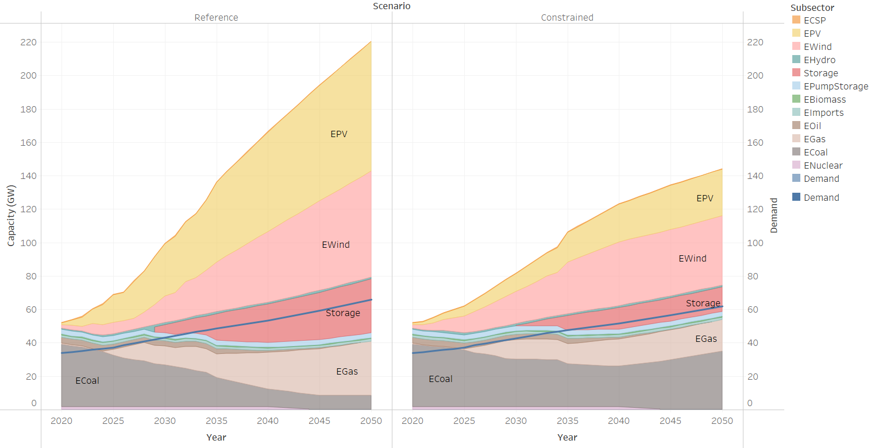

Figure 7: Comparison of electricity sector capacity

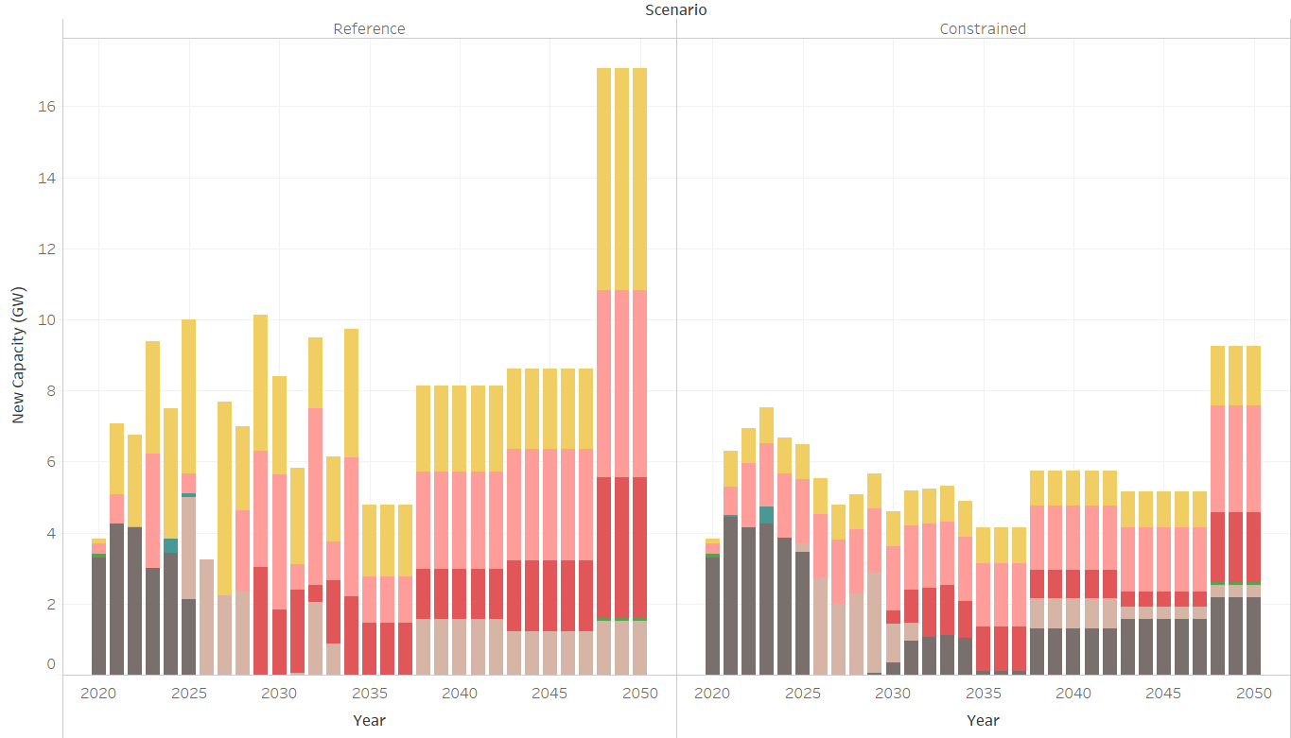

Figure 8: Annual new capacity additions

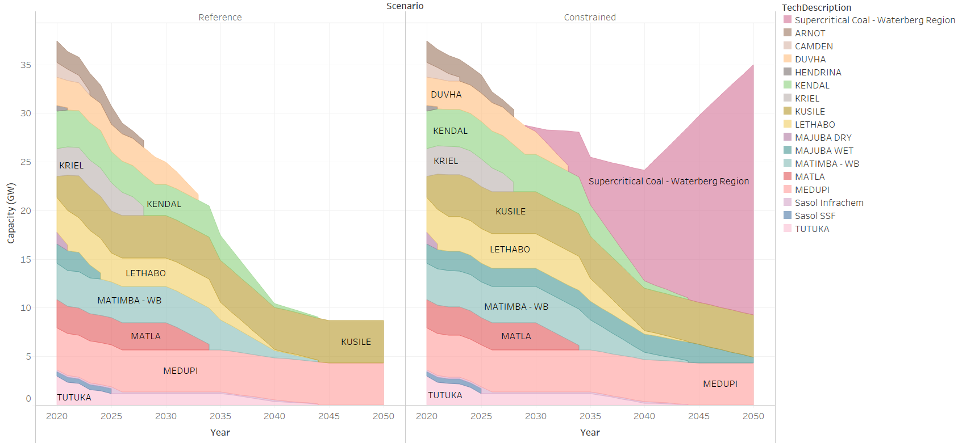

Figure 9: Comparison of coal capacity

Table 3 Selected coal MES retrofits

|  |  |  |  |  |  |  |  |
| --- | --- | --- | --- | --- | --- | --- | --- |
| Coal power station | Majuba Wet | Kendal | Lethabo | Matla | Duvha | Matimba-WB | Tutuka |
| Reference scenario |  | 3 200 | 2 950 | 2 782 | 2 825 | 3 720 | 1 190 |
| Constrained scenario | 1 894 | 3 840 | 3 540 | 2 782 | 2 900 | 3 720 | 1 190 |

Figure 10 shows the supply and demand for coal in the Reference scenario, showing in detail which mines the coal is coming from. As one can see, around half the supply (in energy terms) is coming from mines that fall outside the current detailed coal mines dataset, which are characterized in a more generic way according to Merven (2016). In the Reference scenario, coal demand declines in all sectors, except in the industry sector, where we see a slight increase. The figure shows that the Secunda coal-to-liquids (CTL) plant is exogenously set to phase out between 2035 and 2040, and the assumed trajectory for coal exports, as per Huxham et al. (2019). The same trajectories for the CTL plant and exports are assumed in the Constrained scenario, which also sees growth in coal use from 2040 (as more coal plants are built to meet growing demand), after a slower decline until then, compared to the Reference scenario.

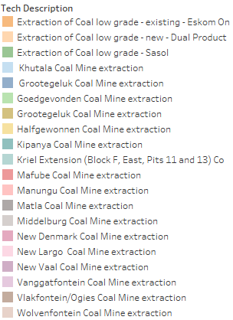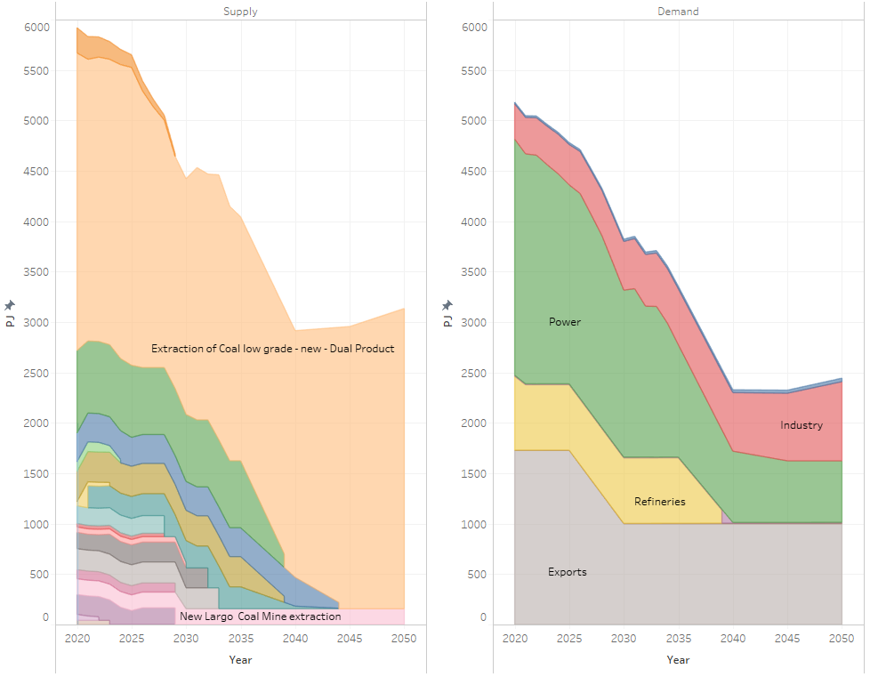

Figure 10: Coal supply and demand for the Reference case

## GDP and employment impact

The economic impact of constraining renewable energy in the electricity mix, as per the constrained scenario, is found to be negative in the long term, with little impact on the economy in the short-to-medium term. By 2050, the level of real GDP is 2.8% lower in the Constrained scenario relative to the Reference case, with ~1 million fewer jobs being created (see Figure 11). The negative impact is driven by lower GDP across sectors (see Figure 12), although the largest contributor to the decline, due to its size, is the services sector. Overall GDP in the mining sector is lower than in the reference case despite higher GDP in the coal mining sub-sector.



Figure 11: Change in real GDP and employment levels relative to the Reference case



Figure 12: Change in sector GDP level and employment in 2050 relative to the Reference case

The metals manufacturing sector, which comprises the iron and steel, non-ferrous and metal products sub-sectors, is the most negatively affected, with the level of real GDP in the sector 6.7% lower by 2050 in the Constrained scenario relative to the Reference case. Employment in the sector decreases by ~35 000. The non-ferrous and iron and steel sub-sectors are among the five most electricity intensive sub-sectors in the economy. Other electricity-intensive sectors, such as other mining (total mining excluding coal mining), are also amongst the most negatively affected sectors, with the level of real GDP in the sector 5.5% lower than in the reference case and employment ~36 000 less.

Real GDP in the coal-mining sector is higher in the Constrained case due to continued coal use for power generation. The coal-mining sector real GDP is 30% higher with ~14 000 more jobs created. This increase is, however, small and only contributes 0.16 percentage points to total GDP and is unable to offset the decline in activity and employment in other sectors of the economy (see Figure 13). A large proportion of employment in the coal-mining sub-sector is made of secondary and tertiary skills (Grades 12 and higher) as opposed to unskilled labour, as is often assumed. Limiting the inclusion of renewable energy does not, therefore, protect a large share of unskilled jobs. Instead, the cap on renewable energy power capacity limits the potential to create employment for lower-skilled workers in other sectors of the economy. There is a clear trade-off between protecting the coal-mining sector and thus coal employment through artificially increasing the use of coal in the power sector and the creation of jobs across the economy.

Figure 13: Change in sector employment by skill by 2050 relative to the Reference case

The negative impact is driven by higher investment in the power sector in the Constrained scenario relative to the Reference case as well as by the higher electricity price, which is also driven by the coal fuel cost. By 2050, cumulative investment in the constrained scenario is 17% (ZAR 389 bn) higher than in the reference case. The electricity price is nearly 40% or ZAR 0.33 (2015 ZAR/kWh) higher (see Figure 14).

Figure 14: Average unit cost of electricity and cumulative investment in the electricity sector

Total and power sector emissions are higher in the Constrained scenario than in the Reference case (see Figure 15). By 2050, total emissions are 172 Mt CO2-eq higher in the RE Constrained scenario than in the Reference case and power sector emissions are 170 Mt CO2-eq higher.

Figure 15: Total (excluding waste and AFOLU) and power sector emissions by scenario

# Conclusion

This paper has presented an updated modelling methodology for analysing energy and emissions pathways for South Africa and their corresponding impacts on economic development. The updated methodology includes higher detail of the coal and electricity sectors in the energy model and strengthens the relationship between these sectors in the hard-linked energy-economic model (thus improving the consistency between the two models). A key advancement in the methodology is the improved link to employment impacts through explicit technology-specific labour intensities.

The updated framework provides useful information for policy development aimed at limiting the costs to the economy of changes in the energy system. As illustrated, the outputs from the framework present the timing of power station ramp downs and closures and the associated impacts on coal demand declines linked to these and the respective mines. The methodology furthermore allows for identification and costing of refurbishments needed to the existing power fleet to ensure that they are legislatively compliant as in McCall et al. (2019).

As a model application, the paper assesses the economic impacts of constraining renewable energy capacity in electricity production relative to not doing so. The key findings from this analysis shows that, with rising coal costs and lower coal export demand, persisting with coal-based power generation does not “save jobs” in South Africa at the aggregate level. Relative to the reference case, the constrained scenario results in ~1 million fewer jobs being created in the economy (net the jobs saved in coal-mining), including fewer unskilled jobs. Apart from the higher investment levels needed in the constrained scenario, the electricity price is also higher, negatively affecting production, particularly in electricity-intensive sectors which are also key export sectors. Furthermore, the results show that lost coal-based power generation jobs are more than offset by increased employment in other generation technologies, such as solar PV and wind.

Constraining renewable additions also limits the ability of South Africa to reduce its emissions and achieve the set-out Nationally Determined Contribution. As is well understood, decarbonization in the power sector is key to reducing national emissions, and the only way to do this is to reduce the level of coal used in power generation. Policymakers therefore need to address the challenges facing coal-producing regions and develop policies that enable new activities in these regions and also assist displaced workers to transition into other employment opportunities.

While the paper includes several of the necessary links for improved analysis of the impacts of a transition away from coal (e.g. employment intensity by power plant, coal supply source per plant and the structure to include employment intensity by coal mine) further research and data are required to strengthen and enhance these links and more fully capture the cost of energy transitions. The most critical of these is the availability of data, particularly that of employment by mine and by levels of education and skills amongst workers. More information is also needed to better understand and model coal demand and supply outside of the power sector. Further research on the geographic and sectoral (im)mobility of labour is also needed to better account for and understand the costs of transitions in the energy system and the policy responses needed to mitigate these.

# References

Alton, T., C. Arndt, R. Davies, F. Hartley, K. Makrelov, J. Thurlow, and D. Ubogu (2014). Introducing carbon taxes in South Africa. *Applied Energy* 116: 344-354.

Arndt, C., Davies, R., Gabriel, S., Makrelov, K., Merven, B., Hartley, F. and Thurlow, J. 2016. A sequential approach to integrated energy modelling in South Africa.  *Applied Energy* 161: 591-599.

Burton, J., Caetano, T. and McCall, B. 2018. Coal transitions in South Africa: Understanding the implications of a 2C-compatible coal phase out plan for South Africa. Energy Research Centre, University of Cape Town, Cape Town.

Dentons, 2015. Report in respect of the investigation into the status of the business and challenges experienced by Eskom. 2 July 2015.

Dervis. K., de Melo, J. and Robinson, S. 1982. *General equilibrium models for development policy.* New York, USA: Cambridge University Press.

Diao, X. and Thurlow, J. 2012. A recursive dynamic computable general equilibrium model. In: Diao, X., Thurlow, J., Benin, S. and Fan, S. (eds), *Strategies and priorities for African agriculture: Economywide perspectives from country studies*. Washington DC, USA: International Food Policy Research Institute.

DoE [Department of Energy]. 2012. *South African energy price report 2012.* Energy Data Collection, Management and Analysis Directorate, Pretoria.

DoE [Department of Energy]. 2015. Integrated energy plan Annexure B: Macroeconomic sssumptions

DMRE [Department of Mineral Resources and Energy]. 2019. *The integrated resource plan 2019*. *Government Gazette* Vol. 652 No. 42778, Republic of South Africa.

EC [European Communities]. 2009. System of national accounts 2008. European Communities, International Monetary Fund, Organisation for Economic Co-operation and Development, United Nations and World Bank.

Eskom. 2019. The Koeberg experience. Available at: <http://www.eskom.co.za/Whatweredoing/ElectricityGeneration/KoebergNuclearPowerStation/TheKoebergExperience/Pages/The_Koeberg_Experience.aspx> [Accessed 23/10/2019]

Hartley, F., Merven, B., Hughes, A. and Dekenah, M. 2019a. Spatial energy in South Africa. Energy Research Centre, University of Cape Town: Cape Town, South Africa.

Hartley, F., Merven, B., Arndt, C. and Ireland, G. 2019b. Part 2 - Quantifying the macro and socioeconomic benefits of a transition to renewable energy in South Africa. SA-TIED working paper 26.

Hughes, A., Merven, B., McCall, B., Caetano, T., Hartley, F., Ahjum, F., Ireland, G., Burton, J. and Marquard, A. 2019. SATIM - An energy systems model for South Africa. Working Paper.

Huxham, M., Anwar, M. and Nelson, D. 2019. Understanding the impact of a low carbon transition on South Africa. A CPI Energy Finance Report. Climate Policy Initiative.

IMF [International Monetary Fund]. 2018. *World economic outlook. Challenges to steady growth.* October 2018.

Ireland, G. and Burton, J. 2018. An assessment of new coal plants in South Africa's electricity future: the cost, emissions, and supply security implications of the coal IPP programme. Energy Research Centre, University of Cape Town, Cape Town, South Africa.

Lofgren, H., Harris, R.L. and Robinson, S. 2002. A standard computable general equilibrium (CGE) model in GAMS. Washington DC, USA: International Food Policy Research Institute.

McCall, B., Burton, J., Marquard, A., Hartley, F., Ahjum, F., Ireland, G. and Merven, B., 2019. Least-cost integrated resource planning and cost-optimal climate change mitigation policy: Alternatives for the South African electricity system. *Energy Research.*

McKinsey. 2014. Socio-economic impact study, McKinsey.

Merven, B, Durbach, I and McCall, B. 2016. Expert elicitation of autocorrelated time series with application to e3 (energy-environment-economic) forecasting models. *Environmental Modelling & Software* 88 (February 2017): 93-105.

Merven, B., Arndt, C. and Winkler, H. 2017. The development of a linked modelling framework for analysing the socioeconomic impacts of energy and climate policies in South Africa. WIDER Working Paper, no. 2017/40.

Merven, B., G. Ireland, F. Hartley, C. Arndt, A. Hughes, F. Ahjum, B. McCall, and T. Caetano (2018). Quantifying the macro- and socio-economic benefits of a transition to renewable energy in South Africa. Part 1: The Energy Landscape. Working Paper. Pretoria: South Africa – Towards Inclusive Economic Development.

Merven, B., Hartley, F. and Ahjum, F. 2019. Road freight and energy in South Africa. SA-TIED working paper 60.

National Treasury. 2018. *Medium term budget policy statement*. Chapter 2. Republic of South Africa.

NERSA [National Energy Regulator of South Africa]. 2012. Report on the electricity supply statistics for South Africa. Available at <http://www.nersa.org.za/Admin/Document/Editor/file/News%20and%20Publications/Publications/Current%20Issues/Electricity%20Supply%20Statistics/Electricity> [Accessed 23/10/2019]

Reber T, Chartan J, Erol K, Brinkman GL. 2018. Preliminary findings of the South Africa power system capacity expansion and operational modelling study: preprint. Rep., US Dep. Energy, Washington, DC.

StatsSA [Statistics South Africa] www.statssa.gov.za

Steyn, G., Burton, J. and Steenkamp, M., 2017. Eskom's financial crisis and the viability of coal-fired power in South Africa. Cape Town, South Africa.

Tosato, G. C. 2008. Introduction to ETSAP and the MARKAL-TIMES models generators. International Energy Agency: NEET Workshop on Energy Technology Collaboration. Available http://www.iea.org/textbase/work/2008/neet_russia/GianCarlo_Tosato.pdf [Accessed 21/03/2019]

UNEP [United Nations Environmental Programme].2016. Obtaining long-term forecasts of the key drivers of greenhouse gas emissions in South Africa. UNEP-DTU Partnership/ERC/FIRM. Copenhagen: United Nations Environment Programme.

Van Seventer, D., Hartley, F., Gabriel, S. and Davies, R. 2016. A 2012 social accounting matrix (Sam) for South Africa'. 2016/26. Helsinki: UNU-WIDER.

Wright JG, Bischof-Niemz T, Calitz J, Mushwana C, van Heerden R, Senatla M. 2017. Formal comments on the Integrated Resource Plan (IRP) Update Assumptions, Base Case and Observations. Rep., Counc. Sci. Ind. Res., Pretoria, S. Afr.

About the authors

Bruno Merven, Faaiqa Hartley, Bryce McCall, Jesse Burton and Jules Schers are researchers within the Energy Systems Research Group at the University of Cape Town. All are involved in the development and maintenance of the group’s energy, economic and linked energy-economic model.

Acknowledgments

The authors would like to acknowledge funding provided for this research by the SA-TIED (<http://sa-tied.wider.unu.edu/>) project in collaboration with IFPRI, and funding from the South African National Energy Development Institute (SANEDI).

1. Average of rounds 1-3.
2. From derived values in Table 1.